Learn how to use sensory stimulation to relieve stress on the spot and stay calm, productive, and focused—no matter what life throws at you.
At Opt4health we specialise in stress detection and relieve it by means of non-evasive celluar re-balancing. Ever wish a stress superhero could save you from the tension of traffic jams, chaotic meetings, arguments with your spouse, or a toddler’s tantrums? You can be that hero by learning to reduce the impact of stress as it’s happening. Learning this skill takes time, experimentation, and practice—but the payoff is huge. You can stay calm, productive, and focused when you know how to quickly relieve stress.

What is the fastest way to relieve stress?
There are countless techniques for managing stress. Yoga, mindfulness meditation, and exercise are just a few examples of stress-relieving activities that work wonders. But in the heat of the moment, during a high-pressured job interview, for example, or a disagreement with your spouse, you can’t just excuse yourself to meditate or take a long walk. In these situations, you need something more immediate and accessible.
One of the speediest and most reliable ways to stamp out stress is to engage one or more of your senses—sight, sound, taste, smell, touch—or through movement. But since everyone is different, you’ll need to do some experimenting to discover which technique works best for you.
Social interaction is your body’s most evolved and surefire strategy for regulating the nervous system. Talking face-to-face with a relaxed and caring listener can help you quickly calm down and release tension. Although you can’t always have a pal to lean on in the middle of a stressful situation, maintaining a network of close relationships is vital for your mental health. Between sensory-based stress relief and good listeners, you’ll have your bases covered.

Tip 1: Recognize when you’re stressed
It might seem obvious that you’d know when you’re stressed, but many of us spend so much time in a frazzled state that we’ve forgotten what it feels like when our nervous systems are in balance: when we’re calm yet still alert and focused. If this is you, you can recognize when you’re stressed by listening to your body. When you’re tired, your eyes feel heavy and you might rest your head on your hand. When you’re happy, you laugh easily. And when you’re stressed, your body lets you know that, too. Get in the habit of paying attention to your body’s clues.
Observe your muscles and insides. Are your muscles tense or sore? Is your stomach tight, cramped, or aching? Are your hands or jaw clenched?
Observe your breath. Is your breathing shallow? Place one hand on your belly, the other on your chest. Watch your hands rise and fall with each breath. Notice when you breathe fully or when you “forget” to breathe.

Tip 2: Identify your stress response
Internally, we all respond the same way to the “fight-or-flight” stress response: your blood pressure rises, your heart pumps faster, and your muscles constrict. Your body works hard and drains your immune system. Externally, however, people respond to stress in different ways.
The best way to quickly relieve stress often relates to your specific stress response:
Overexcited stress response: If you tend to become angry, agitated, overly emotional, or keyed up under stress, you will respond best to stress relief activities that quiet you down.
Underexcited stress response: If you tend to become depressed, withdrawn, or spaced out under stress, you will respond best to stress relief activities that are stimulating and energizing.

The immobilization or “frozen” stress response
Do you freeze when under stress? The immobilization stress response is often associated with
a past history of trauma. When faced with stressful situations, you may find yourself totally stuck and unable to take action. Your challenge is to break free of your “frozen” state by rebooting your nervous system and reactivating the body’s natural “fight-or-flight” stress response. Physical movement that engages both your arms and legs, such as walking, swimming, running, dancing, climbing, or tai chi, can be particularly helpful. As you move, focus on your body and the sensations you feel in your limbs rather than on your thoughts. This mindfulness element can help your nervous system become “unstuck” and move on.

Tip 3: Bring your senses to the rescue
To use your senses to quickly relieve stress, you first need to identify the sensory experiences that work best for you. This can require some experimentation. As you employ different senses, note how quickly your stress levels drop. And be as precise as possible. What is the specific kind of sound or type of movement that affects you the most? For example, if you’re a music lover, listen to many different artists and types of music until you find the song that instantly lifts and relaxes you.
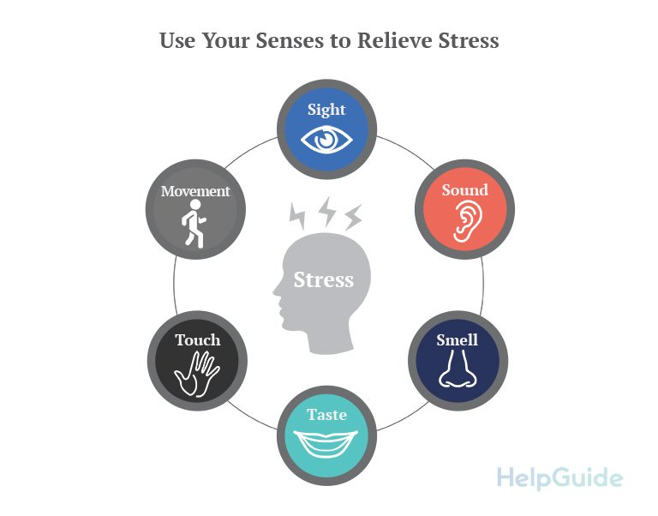
Explore a variety of sensory experiences so that no matter where you are, you’ll always have a tool to relieve stress.
The examples listed below are intended to be a jumping-off point. Let your imagination run free and come up with additional things to try. When you find the right sensory technique, you’ll know it!

Sight
- Look at a cherished photo or a favorite memento.
- Use a plant or flowers to enliven your work space.
- Enjoy the beauty of nature: a garden, the beach, a park, or your own backyard.
- Surround yourself with colors that lift your spirits.
- Close your eyes and picture a place that feels peaceful and rejuvenating.

Smell
- Light a scented candle or burn some incense.
- Experiment with different essential oils.
- Smell the roses or another type of flower.
- Enjoy clean, fresh air in the great outdoors.
- Spritz on your favorite perfume or cologne.

Touch
- Wrap yourself in a warm blanket.
- Pet a dog or cat.
- Hold a comforting object (a stuffed animal, a favorite memento).
- Give yourself a hand or neck massage.
- Wear clothing that feels soft against your skin.

Taste
Slowly savoring a favorite treat can be very relaxing, but mindless eating will only add to your stress and your waistline. The key is to indulge your sense of taste mindfully and in moderation.
- Chew a piece of sugarless gum.
- Indulge in a small piece of dark chocolate.
- Sip a steaming cup of coffee or tea or a refreshing cold drink.
- Eat a perfectly ripe piece of fruit.
- Enjoy a healthy, crunchy snack (celery, carrots, or trail mix).

Movement
If you tend to shut down when you’re under stress or have experienced trauma, stress-relieving activities that get you moving may be particularly helpful.
- Run in place or jump up and down.
- Dance around.
- Stretch or roll your head in circles.
- Go for a short walk.
- Squeeze a rubbery stress ball.

Sound
- Sing or hum a favorite tune. Listen to uplifting music.
- Tune in to the soundtrack of nature—crashing waves, the wind rustling the trees, birds singing.
- Buy a small fountain, so you can enjoy the soothing sound of running water in your home or office.
- Hang wind chimes near an open window.

Vocal toning
As strange as it may sound, vocal toning is a special technique that reduces the stress hormones adrenaline and cortisol. Try sneaking off to a quiet place to spend a few minutes toning before a meeting with your boss and see how much more relaxed and focused you feel. It works by exercising the tiny muscles of the inner ear that help you detect the higher frequencies of human speech that impart emotion and tell you what someone is really trying to say. Not only will you feel more relaxed in that meeting, you’ll also be better able to understand what he’s trying to communicate.

How to tone
Sit up straight and simply make “mmmm” sounds with your lips together and teeth slightly apart. Experiment by changing the pitch and volume until you experience a pleasant vibration in your face and, eventually, your heart and stomach.

Tip 4: Find sensory inspiration
Having trouble identifying sensory techniques that work for you? Look for inspiration around you, from your sights as you go about your day to memories from your past.
Memories. Think back to what you did as a child to calm down. If you had a blanket or stuffed toy, you might benefit from tactile stimulation. Try tying a textured scarf around your neck before an appointment or keeping a piece of soft suede in your pocket.
Watch others. Observing how others deal with stress can give you valuable insight. Baseball players often pop gum before going up to bat. Singers often chat up the crowd before performing. Ask people you know how they stay focused under pressure.
Parents. Think back to what your parents did to blow off steam. Did your mother feel more relaxed after a long walk? Did your father work in the yard after a hard day?
The power of imagination. Once drawing upon your sensory toolbox becomes habit, try simply imagining vivid sensations when stress strikes. The memory of your baby’s face will have the same calming or energizing effects on your brain as seeing her photo. When you can recall a strong sensation, you’ll never be without a quick stress relief tool.

Take a break from technology
Taking a short hiatus from the television, computer, and cell phone will give you insight on what your senses respond to best.
- Try tuning into relaxing music instead of talk radio during your commute. Or try riding in silence for 10 minutes.
- Stuck in a long line at the grocery store? Instead of talking on your phone, take a moment to people watch. Pay attention to what you hear and see.
- Instead of checking email while waiting for a meeting, take a few deep breaths, look out the window, or sip some tea.
- While waiting for an appointment, resist the urge to text and give yourself a hand massage instead.

Tip 5: Make quick stress relief a habit
It’s not easy to remember to use your senses in the middle of a mini—or not so mini—crisis. At first, it will feel easier to just give into pressure and tense up. But with time, calling upon your senses will become second nature. Think of the process like learning to drive or play golf. You don’t master the skill in one lesson; you have to practice until it becomes second nature. Eventually you’ll feel like you’re forgetting something if you don’t tune into your body during challenging times. Here’s how to make it habit:
Start small. Instead of testing your quick stress relief tools on a source of major stress, start with a predictable low-level source of stress, like cooking dinner at the end of a long day or sitting down to pay bills.
Identify and target. Think of just one low-level stressor that you know will occur several times a week, such as commuting. Vow to target that stressor with quick stress relief every time. After a few weeks, target a second stressor and so on.
Test-drive sensory input. If you are practicing quick stress relief on your commute to work, bring a scented handkerchief with you one day, try music another day, and try a movement the next day. Keep experimenting until you find a clear winner.
Have fun with the process. If something doesn’t work, don’t force it. Move on until you find what works best for you. It should be pleasurable and noticeably calming.
Talk about it. Telling friends or family members about the stress-relief strategies you’re trying out will help you integrate them into your life. As an added bonus, it’s bound to start an interesting conversation: everyone relates to the topic of stress.

Tip 6: Practice wherever you are
The best part of sensory-based strategies is the awareness that you have control. No matter where you are or what you’re doing, quick stress relief is within arm’s reach.

Quick stress relief at home
Entertaining. Prevent pre-party jitters by playing lively music. Light candles. The flicker and scent will stimulate your senses. Wear clothes that make you feel relaxed and confident.
Kitchen. Ease kitchen stress by breathing in the scent of every ingredient. Delight in the delicate texture of an eggshell. Appreciate the weight of an onion.
Children and relationships. Prevent losing your cool during a spousal spat by squeezing the tips of your thumb and forefinger together. When your toddler has a tantrum, rub lotion into your hands and breathe in the scent.
Sleep. Too stressed to snooze? Try using a white noise machine for background sound or a humidifier with a diffuser for a light scent in the air.
Creating a sanctuary. If clutter is upsetting, spend 10 minutes each day to tidy. Display photos and images that make you feel happy. Throw open the curtains and let in natural light.

Quick stress relief at work
Meetings. During stressful sessions, stay connected to your breath. Massage the tips of your fingers. Wiggle your toes. Sip coffee.
On the phone. Inhale something energizing, like lemon, ginger, peppermint. While talking, stand up or pace back and forth to burn off excess energy, or take calls outside when possible.
On the computer. Work standing up. Do knee-bends in 10-minute intervals. Suck on a peppermint. Sip tea.
Lunch breaks. Take a walk around the block or in the parking lot. Listen to soothing music while eating. Chat with a colleague.
Your workspace. Place family photos on your desk or mementos that remind you of your life outside the office.

Quick stress relief on the go
In traffic. Play music or listen to an audiobook. Take a different route to see something new. Do neck-rolls at stoplights. Sing in the car to stay awake and happy.
Public transportation. Take a break from reading, cell conversations, and music to tune into the sights and sounds around you. Try noticing something new, even if you’re on the same old bus ride.
Running errands. Wear a special perfume or lotion so you can enjoy it while you rush from place to place. Carry a stress ball in your pocket. Take a mental “snapshot” or “postcard” at each destination.
Waiting in lines. Instead of worrying about time slipping away, focus on your breathing. People watch. Chat with the person ahead of you. Chew a stick of minty gum.

Get more help

For fast and non-evasive stress detection and release visit us at

www.opt4health.co.za or call us on +27823716364
Authors: Robert Segal, M.A., Jeanne Segal, Ph.D., Melinda Smith, M.A., and Lawrence Robinson. Last updated: October 2019.

